General Ledgers ER Diagram
The below ER diagram illustrates the logical structure of various tables and their relationship in Oracle R12 General Ledger application. This ER diagram visualizes the data flow across different entities in General Ledger processes. It's an inclusive diagram and covers the critical components in Oracle General Ledger.
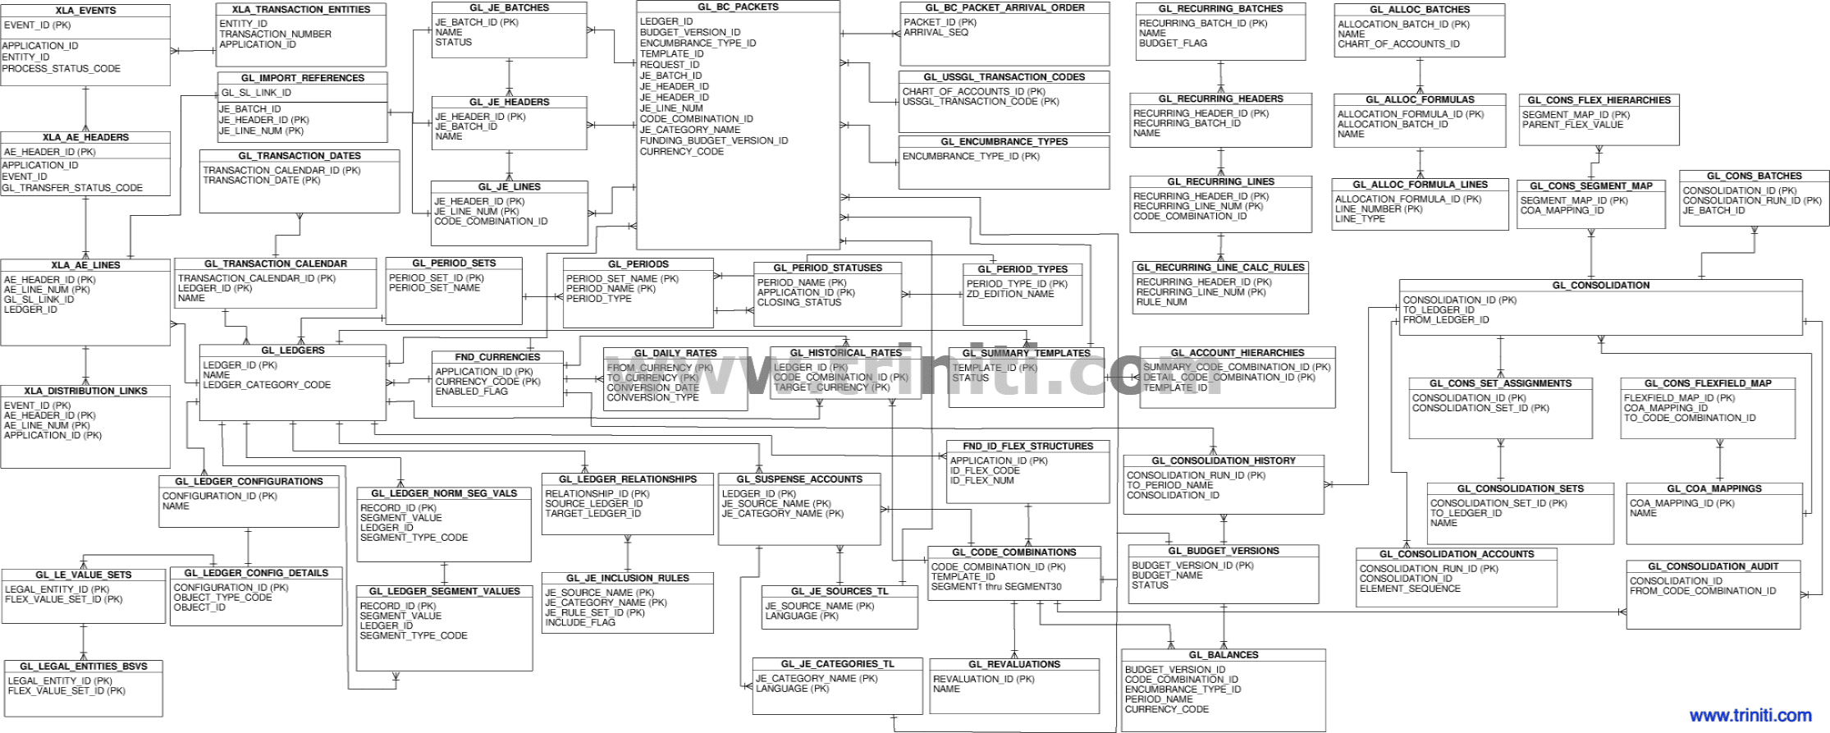

Credit Management ER Diagram
Credit Management ER Diagram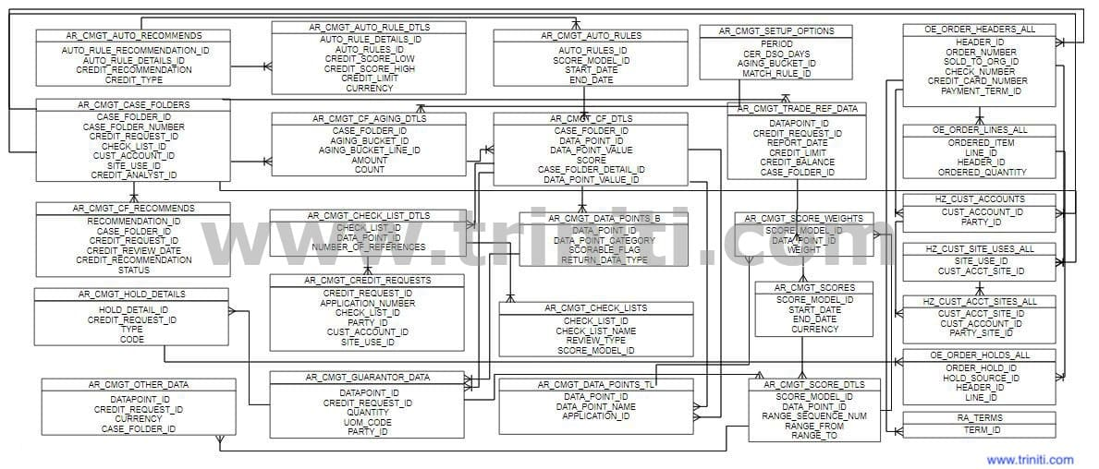

Oracle Install Base ER Diagram
Oracle Install Base ER Diagram
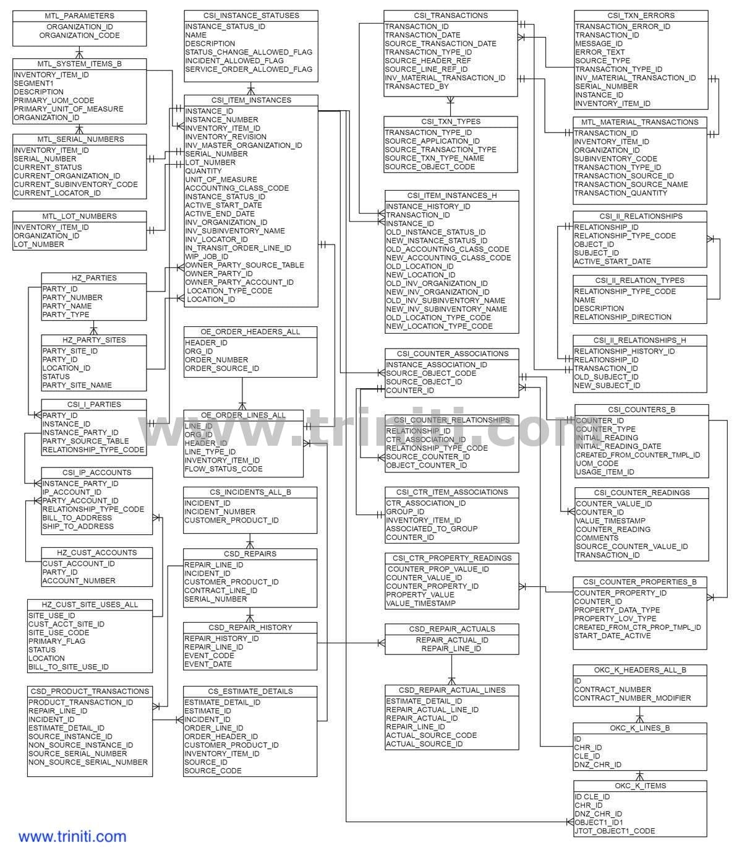

Accounts Receivables ER Diagram
Accounts Receivables ER Diagram illustrates the relationship between Receivables, SLA and General Ledger entities.
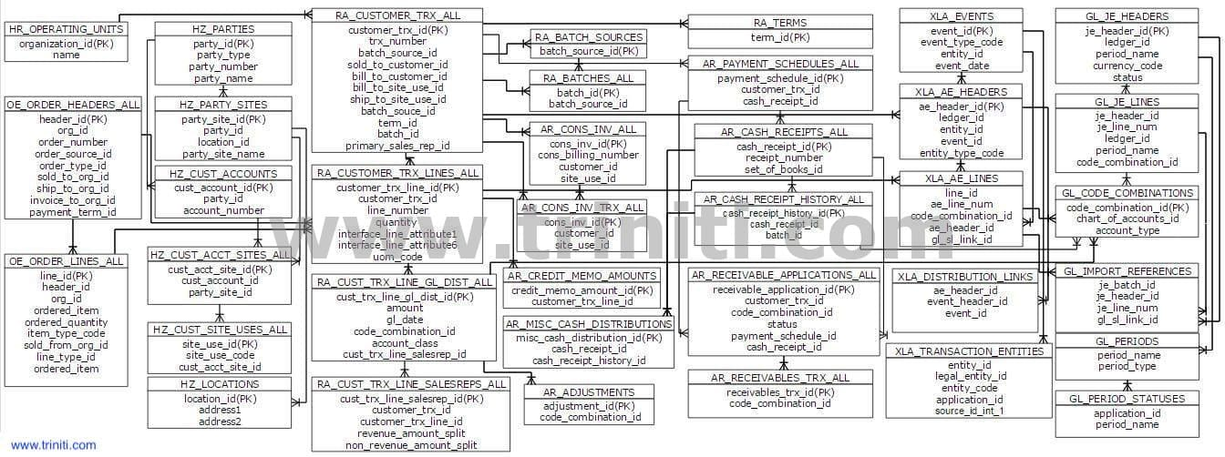

Accounts Payable ER Diagram
Accounts Payable ER Diagram illustrates the relationship between Payables, SLA and General Ledger entities.
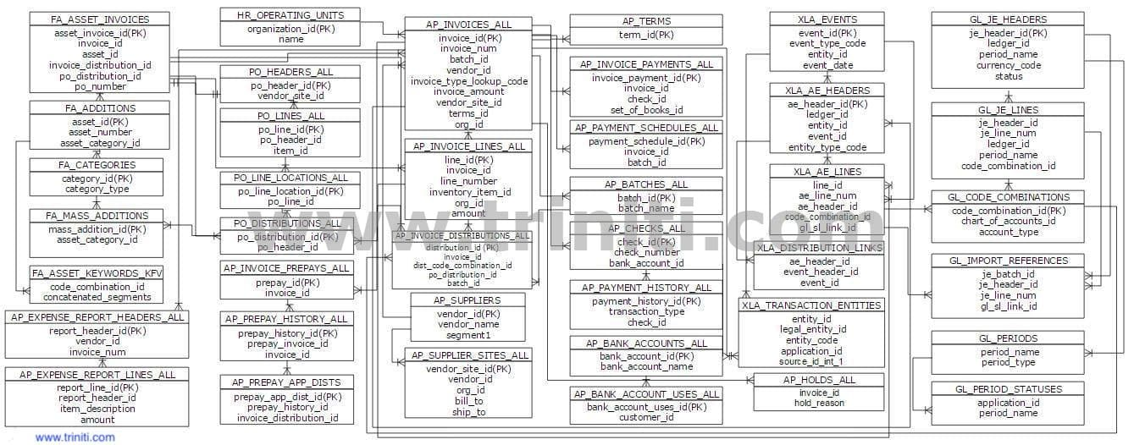

Oracle Advanced Supply Chain Planning (ASCP) ER Diagram
Most of you probably already know this. Plan_id = -1 will be Operational Data Store (ODS collection data) & plan_id <> -1 will be the Planning Data Store (PDS - plan output data). There are a few master data tables like item_categories, trading_partners etc which do not have plan_id columns. This is because the plan does not alter them. We have included them as well in the ER diagram.
Start with MSC_PLANS, which is the master table.
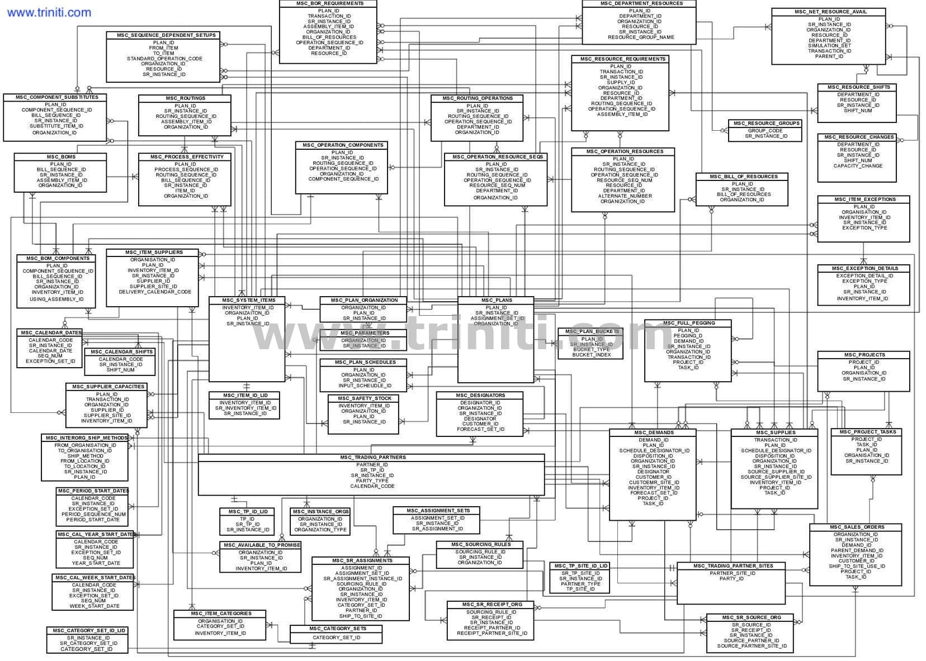

Oracle Order to Cash ER Diagram
The Oracle R12 Order to Cash Module ER diagram shows all O2C tables that are used in Oracle R12 Order to Cash Cycle.
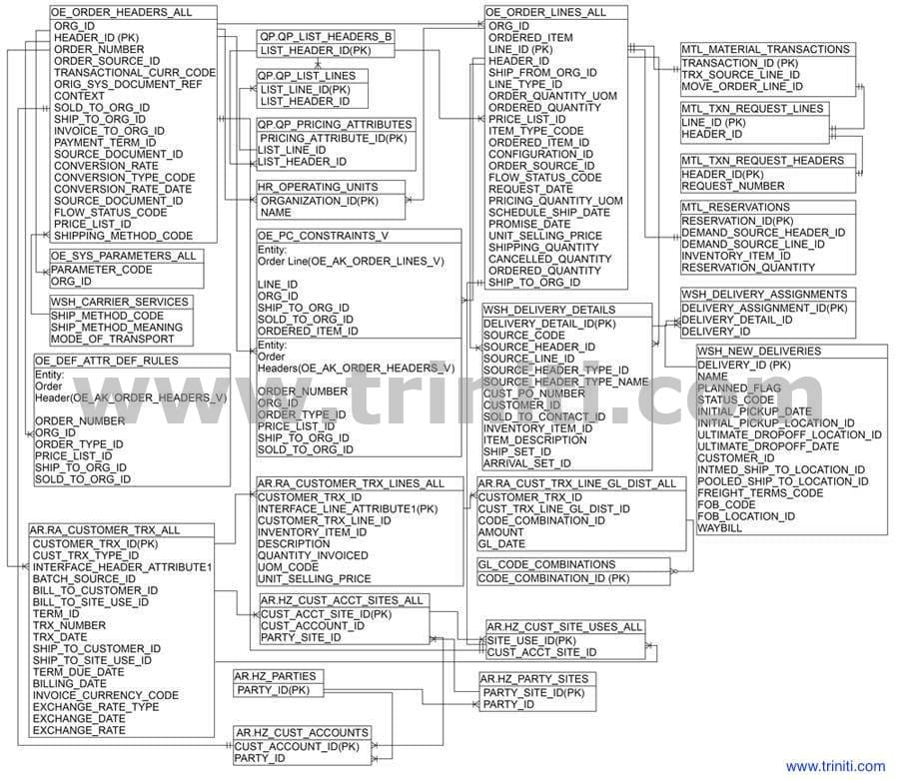

Shop Floor Management ER Diagram
Triniti CEO Srinath Alamela architected Oracle Shop Floor Management (OSFM) in the late 90's as an extension to Oracle Discrete Work in Process(WIP) module. It was to facilitate Manufacturing Execution Systems (MES) such as Workstream, PROMIS etc to be integrated into Oracle at a Lot transaction level. Oracle WIP tracking could not handle complex transactions such as splits, merges prior to OSFM.
Attached is the ER Diagram for this module. It can also be used for Oracle Discrete WIP. Tables with prefix WSM are OSFM specific.
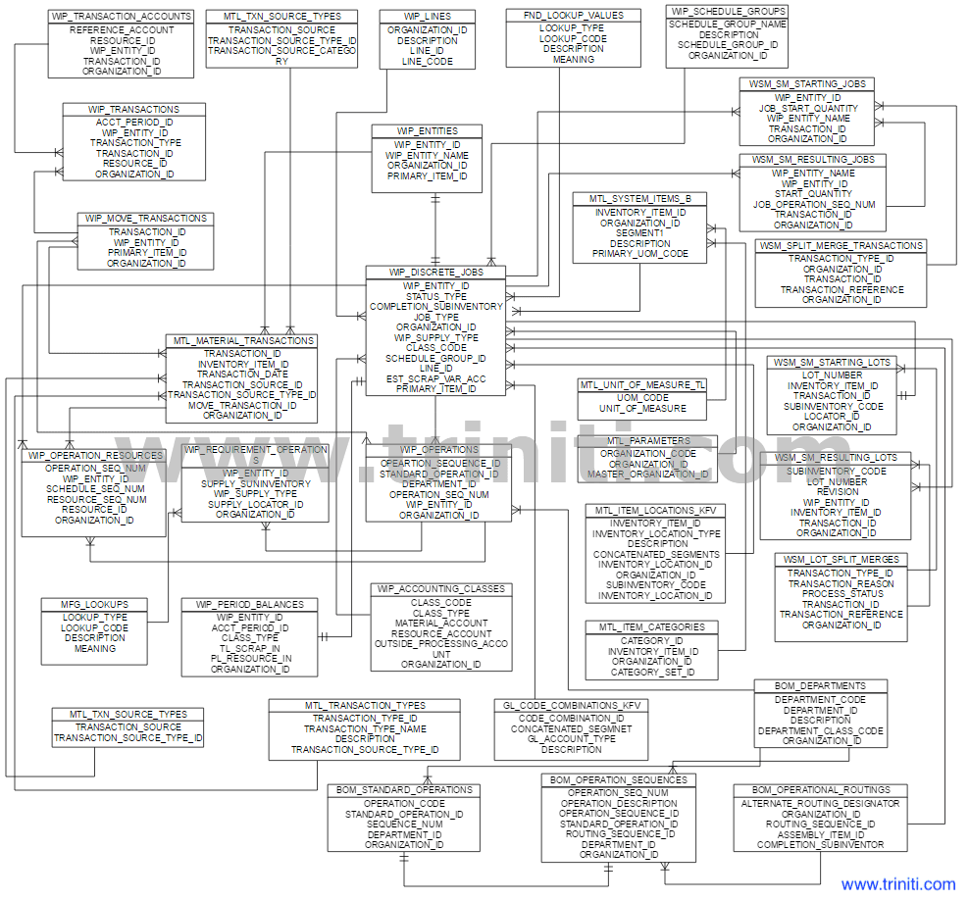

BOM and Routing ER Diagrams
The Oracle R12 Bill Of Materials and Routing ER diagram shows all BOM and Routing tables that are used in Oracle R12 Shop Floor Management.
The Entity Relationship Diagram (ERD) reflects Oracle R12 BOM and Routing Table wise Data Model which illustrates the relation between each table primary key and Reference Table foreign key.

Bill of Materials ER Diagram
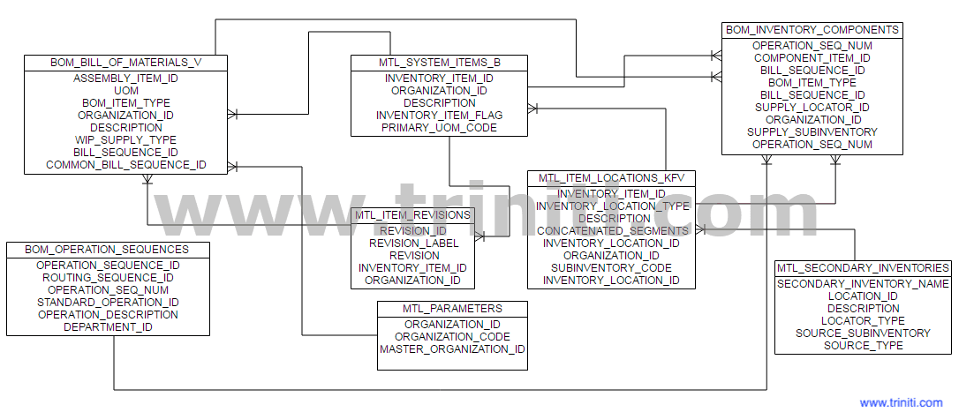
If you are an Arena PLM and Oracle eBusiness Suite user and are struggling to keep the data synchronized, then the Triniti Arena Oracle Adapter is the ideal solution for you. Triniti leverages its pioneering Application Data Management expertise and facilitates out-of-the-box 100% integration in real time. Play the video to know about Triniti Arena Oracle Adapter. To know more about Triniti Arena Oracle Adapter click here.

Routing ER Diagram
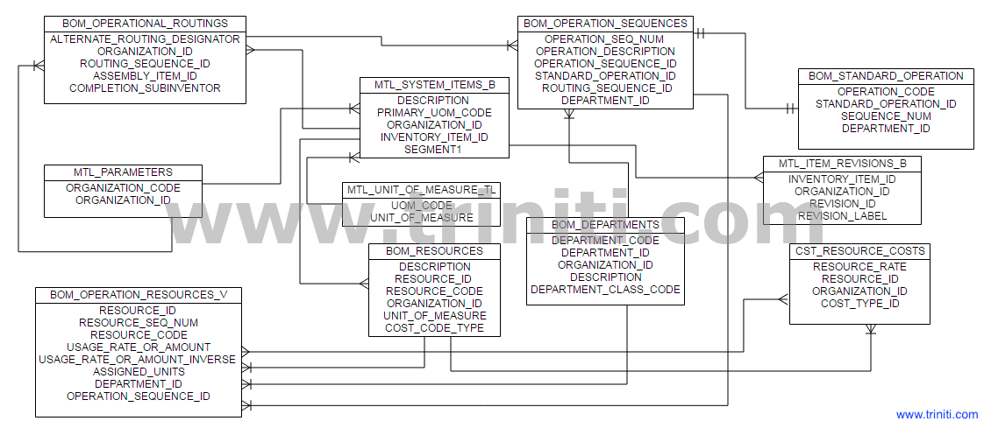

Purchasing ER Diagram
The Oracle R12 Purchasing Module ER Diagram shows all Purchasing and Receiving tables that are used in Oracel R12 PO Module. The Entity Relationship Diagram (ERD) reflects Oracel R12 PO Table wise Data Model which illustrates the relation between each table primary and reference table freign key.
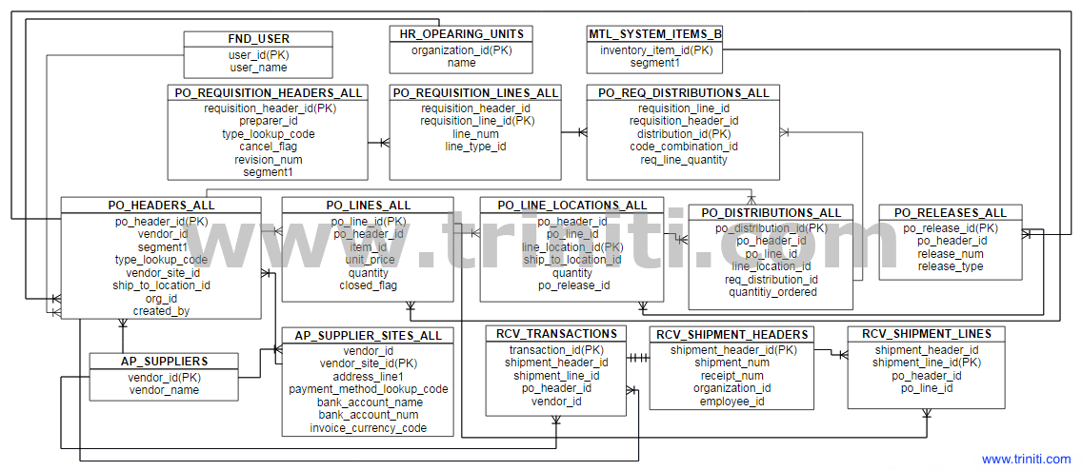

Oracle R12 eBTax ER Diagram
Oracle R12 eBTax ER diagram shows all eBTax tables that are used in Oracle R12 eBTax Module
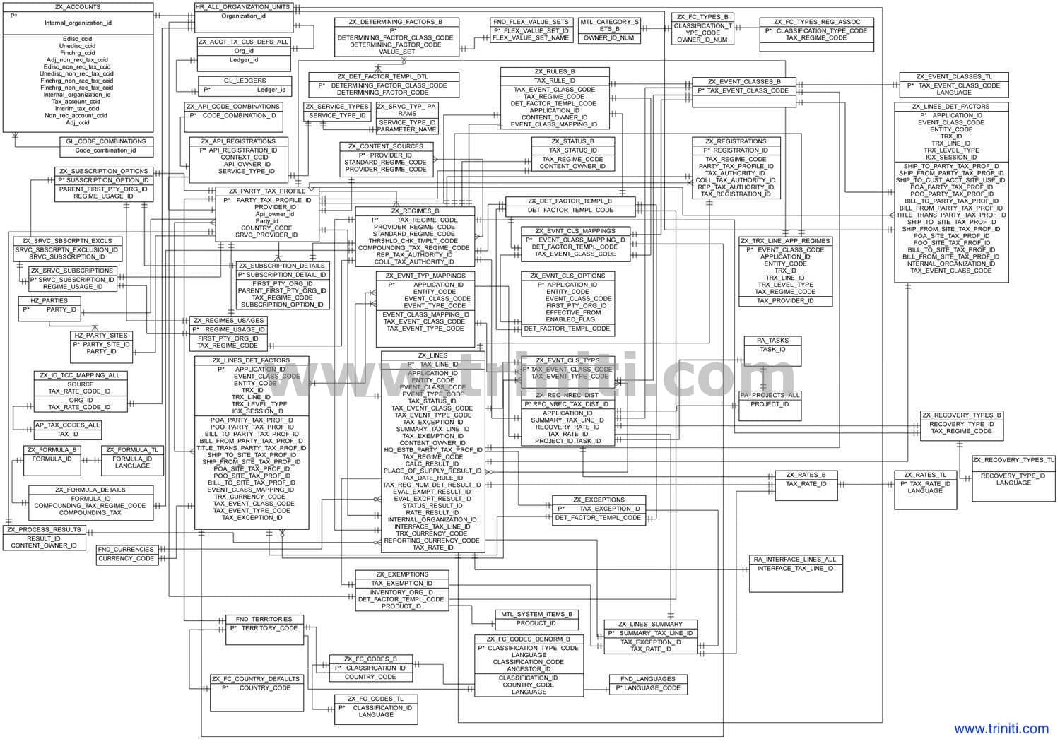

Oracle Advanced Pricing ER Diagram
Oracle Advanced Pricing ER Diagram 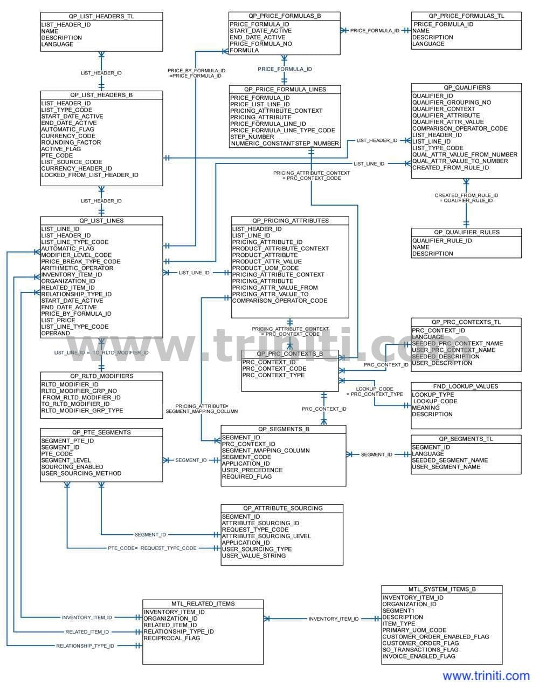

Oracle TCA - Customer Account key primary and foreign key definitions
Oracle EBusiness Suite Trading Community Architecture ER Diagram - a useful guide to writing queries. Limited to only the primary and foreign keys to optimize content on page. We will add the Supplier side as well shortly.
